**Our Remarkable Brain**

Over 50 years ago, Henry M. suffered from epileptic seizures so severe that he could not work. To stop his seizures, surgeons removed a brain structure called the hippocampus. The results of this surgery were both tragic and astonishing:

Henry cannot remember anything new. He can easily recall events from before the operation, but nothing that has happened since. Henry says his world is “like waking from a dream.” He does not know how old he is, nor can he recognize people he has been seeing for years. To this day, he lives from moment to moment, a 70 year old man who is forever 27 years old “in memory.”

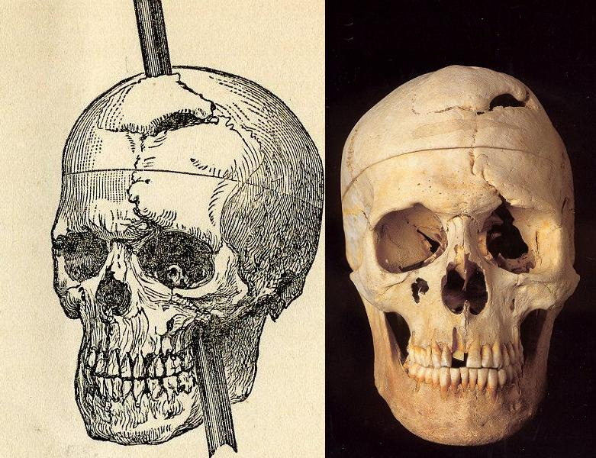

If you had met Phineas Gage before his accident in 1848, you would have liked him. He was a soft-spoken, dependable fellow working as a construction foreman until an explosion at work hurled a thirteen-pound, three-foot-long metal rod into his left cheek and out the top of his head. Incredibly, Phineas was not killed! Instead, he sat up a short time later, rubbed his wound, and asked where his rod went.

Phineas lived another twelve years, but as a different man. He was no longer quiet and reliable, but loud-mouthed, obscene, and an aimless drifter. This dramatic personality change was probably caused by massive damage to his frontal lobe, the part of the brain that helps us make and carry out plans, and behave appropriately in social situations.

In the years following Phineas’ accident, scientists began to develop a “functional map” of the brain that identified which parts of the brain controlled specific functions. Today, scientists continue to learn more details about what parts of the brain do. Here are some of the techniques they use to “map the brain.”

Brain Lesions

Lesions are places where a tiny part of the brain has been removed or destroyed. By making surgical lesions in anesthetized animals and then studying the changes in the animals’ behavior, scientists can learn about the function of different brain areas. Scientists also use chemicals called neurotoxins that destroy specific types of neurons.

Electrical Recording

By recording the electrical current flowing through individual neurons in the brain in active animals, scientists can study the brain’s firing patterns as they happen. That’s how scientists learned that different neurons respond to different small features of a visual scene. It is the combination of all these millions of features that recreate the scene in our brains and allow us to see the world around us.

Your World/Our World: http:// www.bio.com/pba

